**ANALYSING THE PERFORMANCE AND EFFICIENCY OF RADISSON HOTELS USING DATA VISUALIZATION TECHNIQUES**

**INTRODUCTION:**

**Overview:**

The hotel industry is a broad category of businesses that provide lodging services for travellers and tourists. This can include a wide range of establishments, from luxury resorts to budget-friendly motels, as well as extended stay hotels, boutique hotels, and more. Hotels can be found in nearly every corner of the world, and are often a major component of the tourism and travel industry in a given area.

Radisson owns multiple five-star hotels across India. They have been in the hospitality industry for the past 100 years. Due to strategic moves from other competitors and ineffective decision-making in management, Radisson is losing its market share and revenue in the luxury/business hotels category. As a strategic move, the managing director of Radisson wanted to incorporate Business and Data Intelligence in order to regain their market share and revenue. Our task is to create an analytics dashboard & story to provide them insights to make better business decisions.

**Purpose:**

**At Radisson Hotel Group we strive to be the first choice in the mind of guests, owners and talent. In our journey to achieve this, we practice strong beliefs and actions that respect the diversity of people, the community, ethics and the planet.**

**EMPATHY MAP AND BRAIN STORMING MAP:**

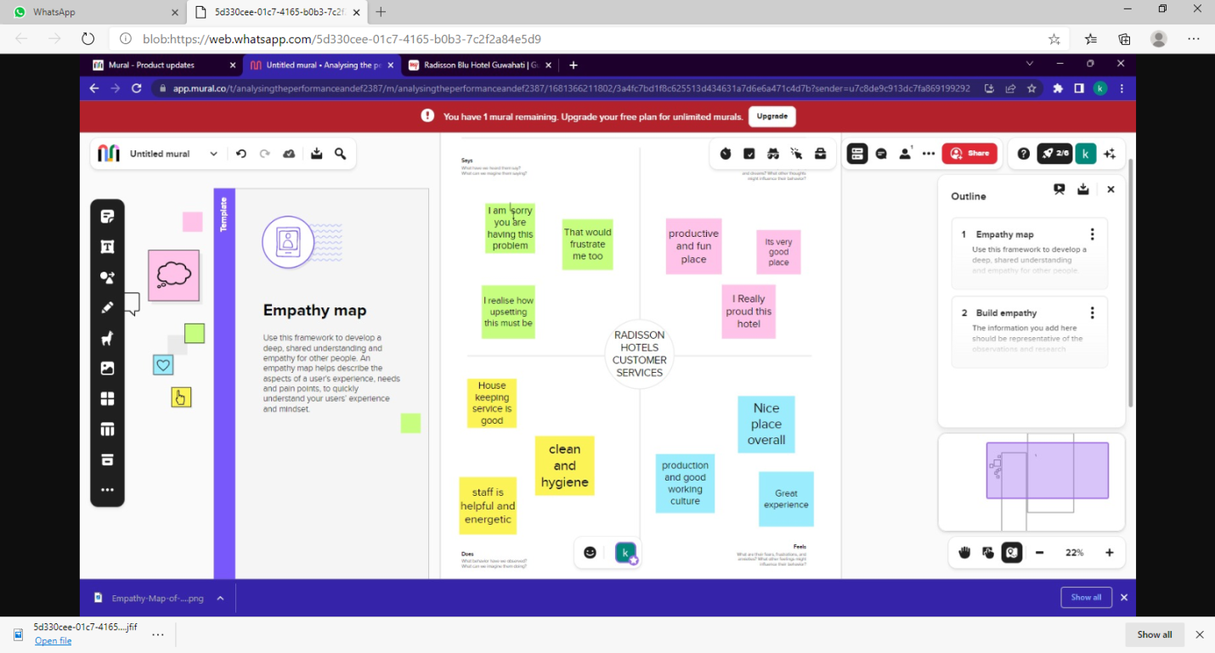

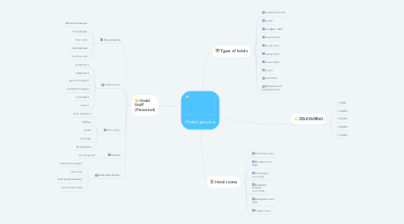

**RESULTS:**

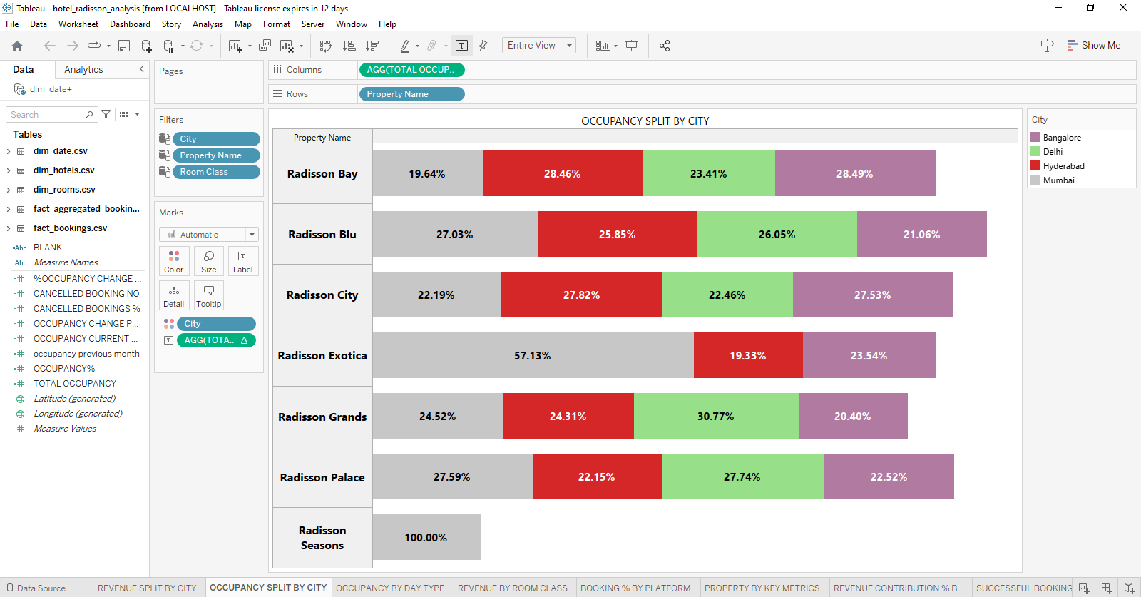

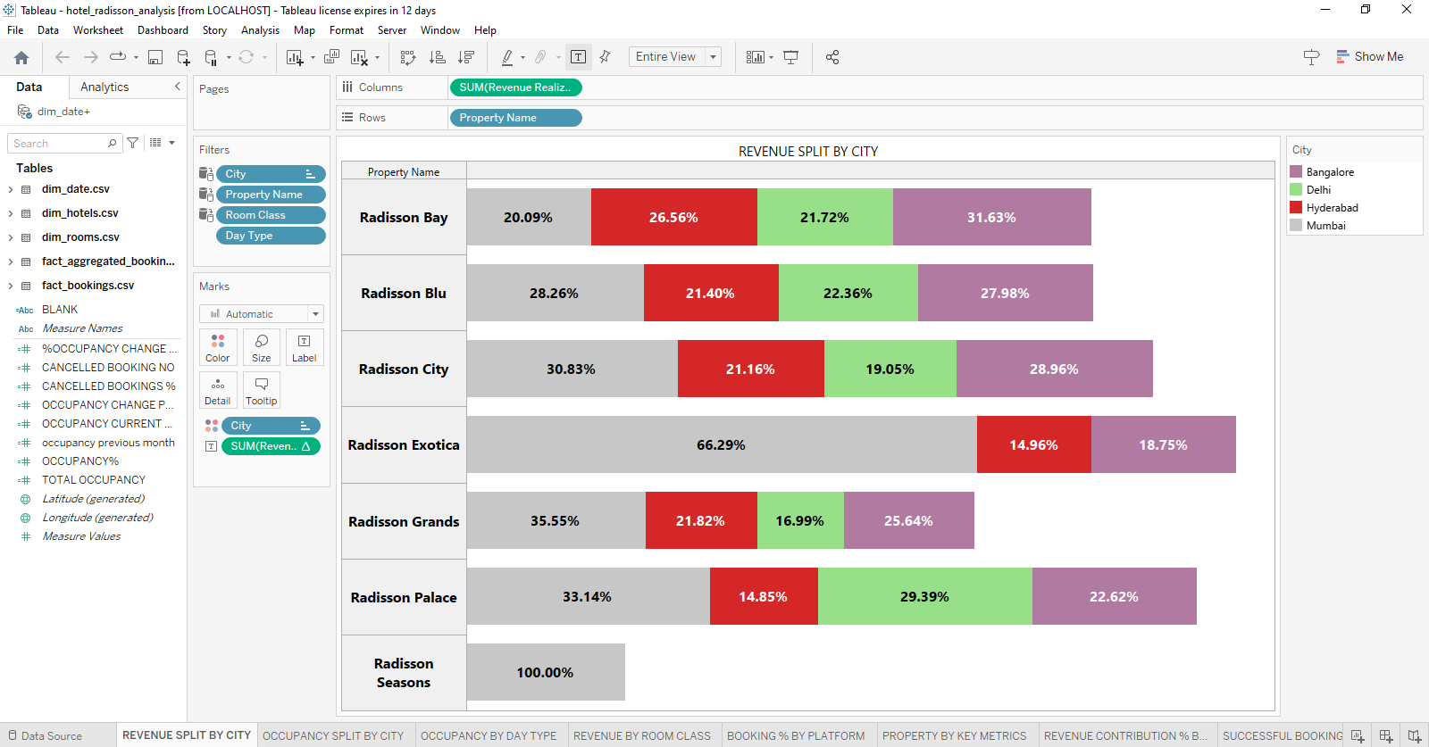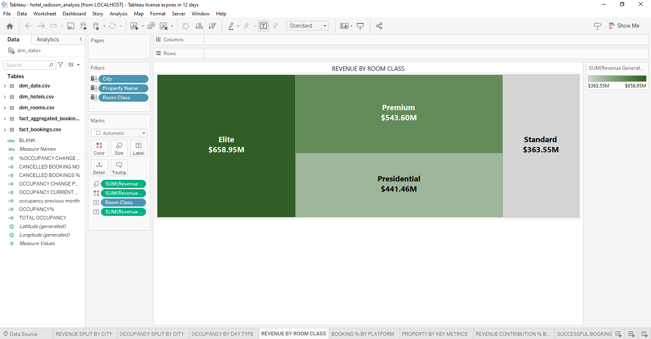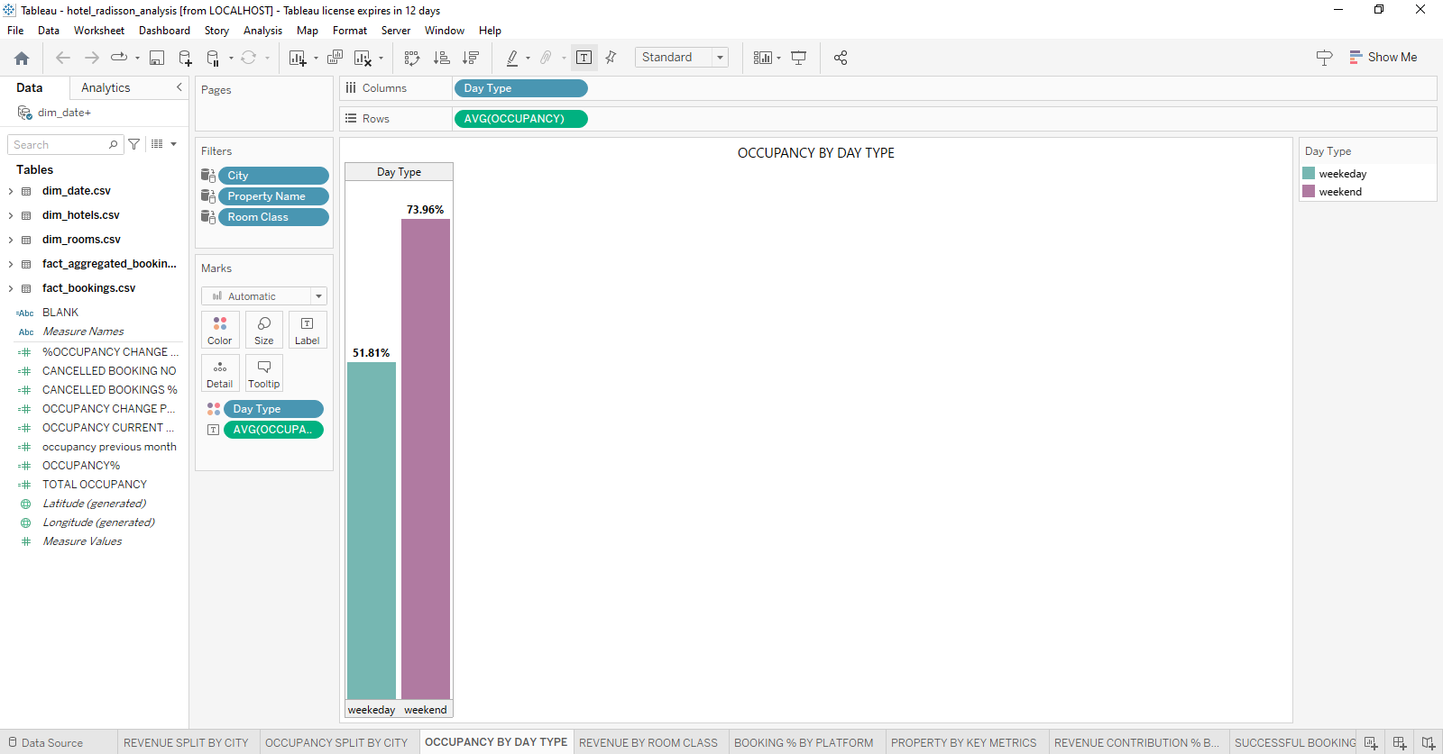

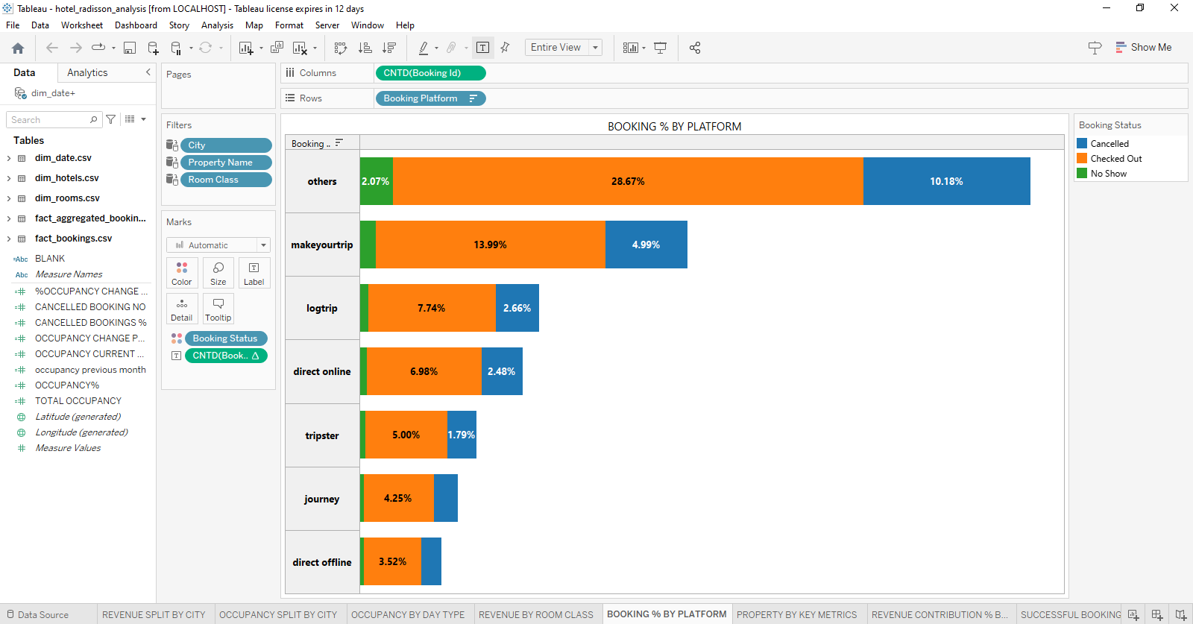

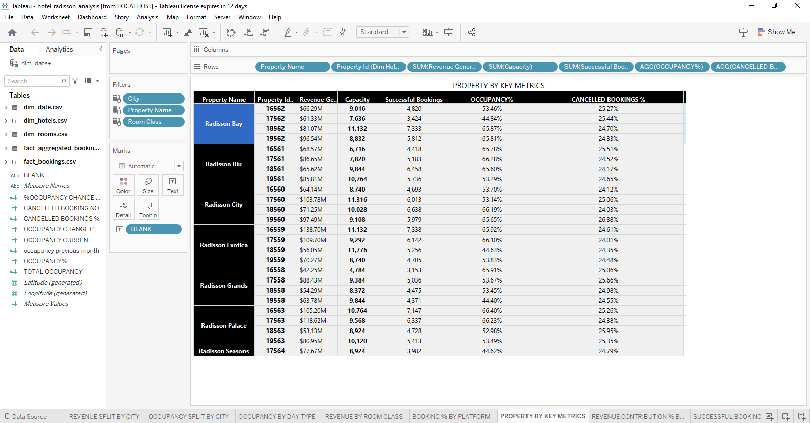

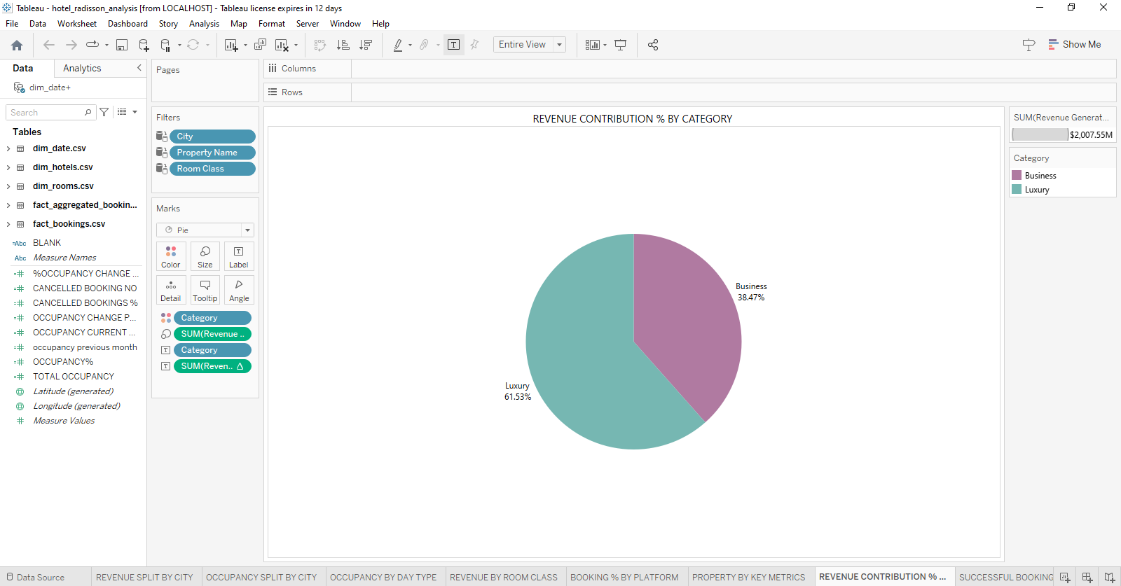

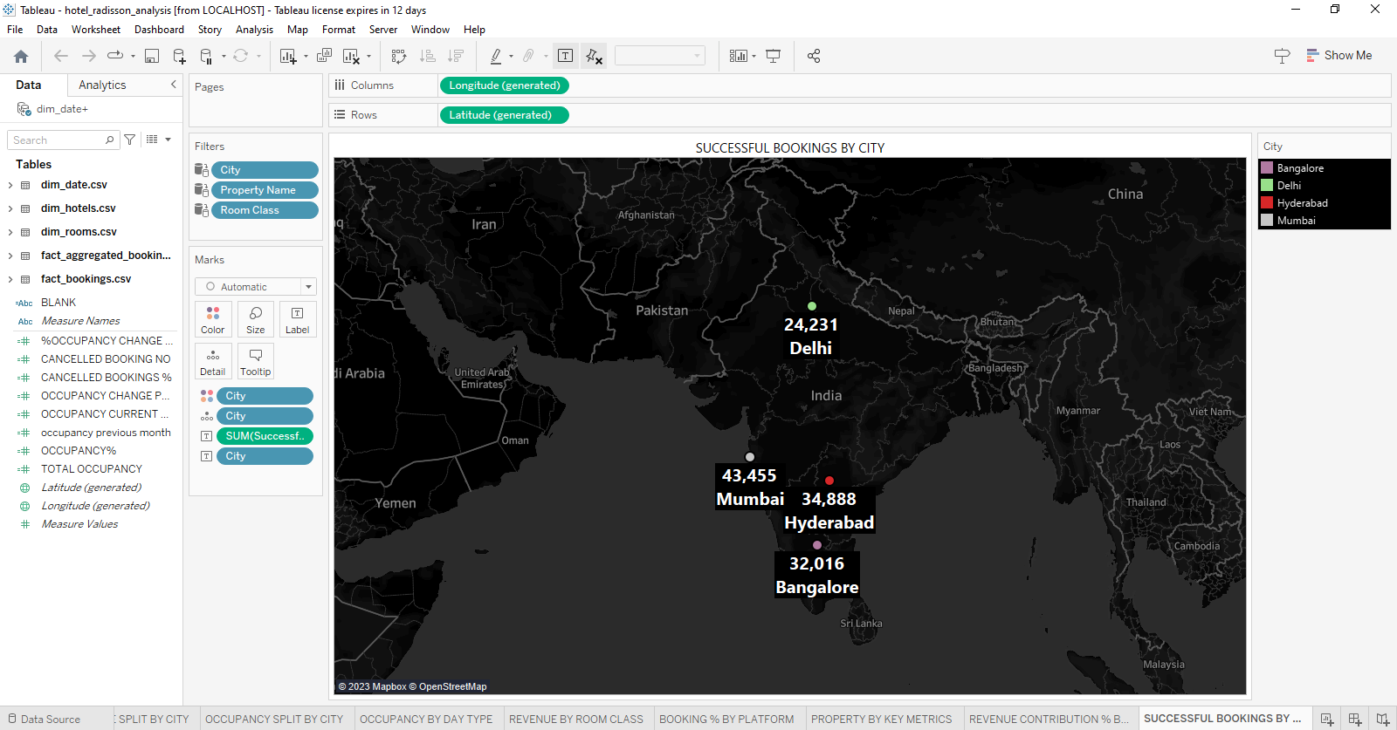

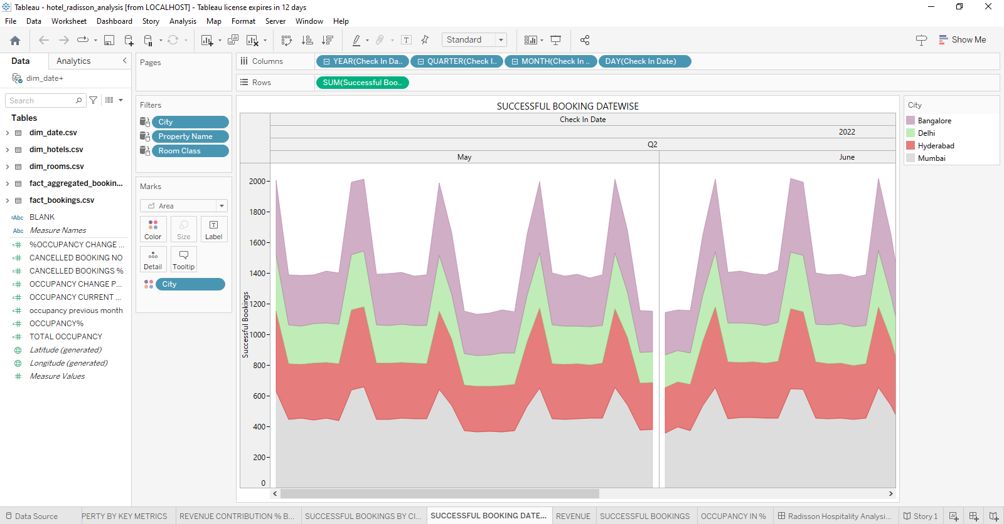

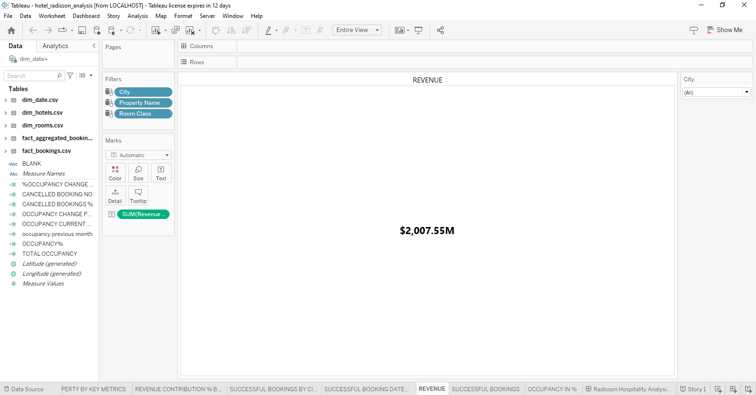

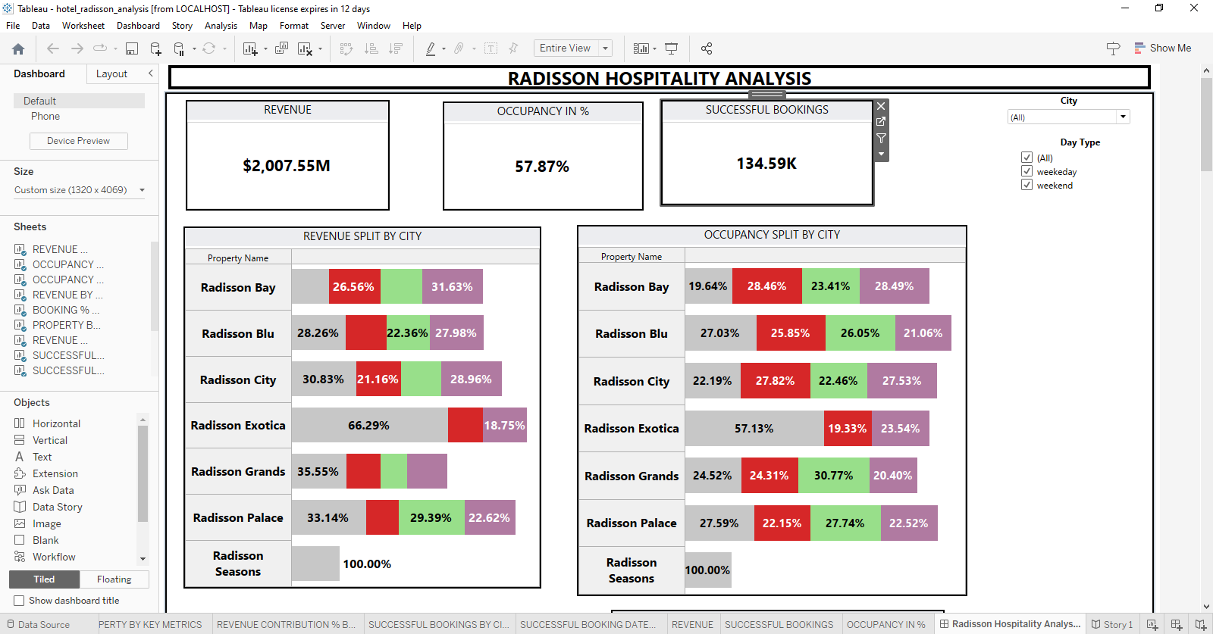

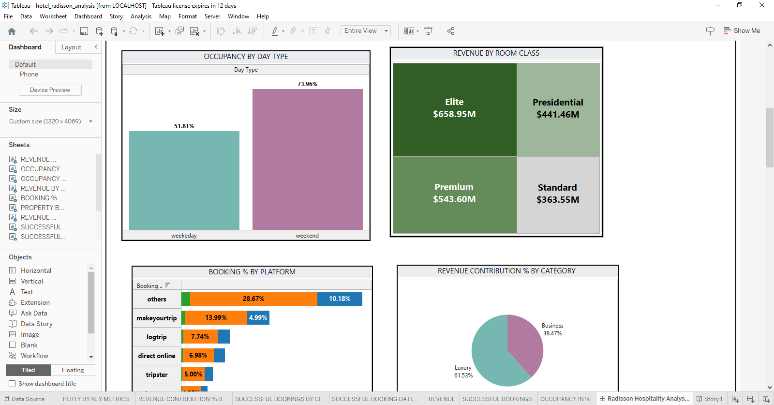

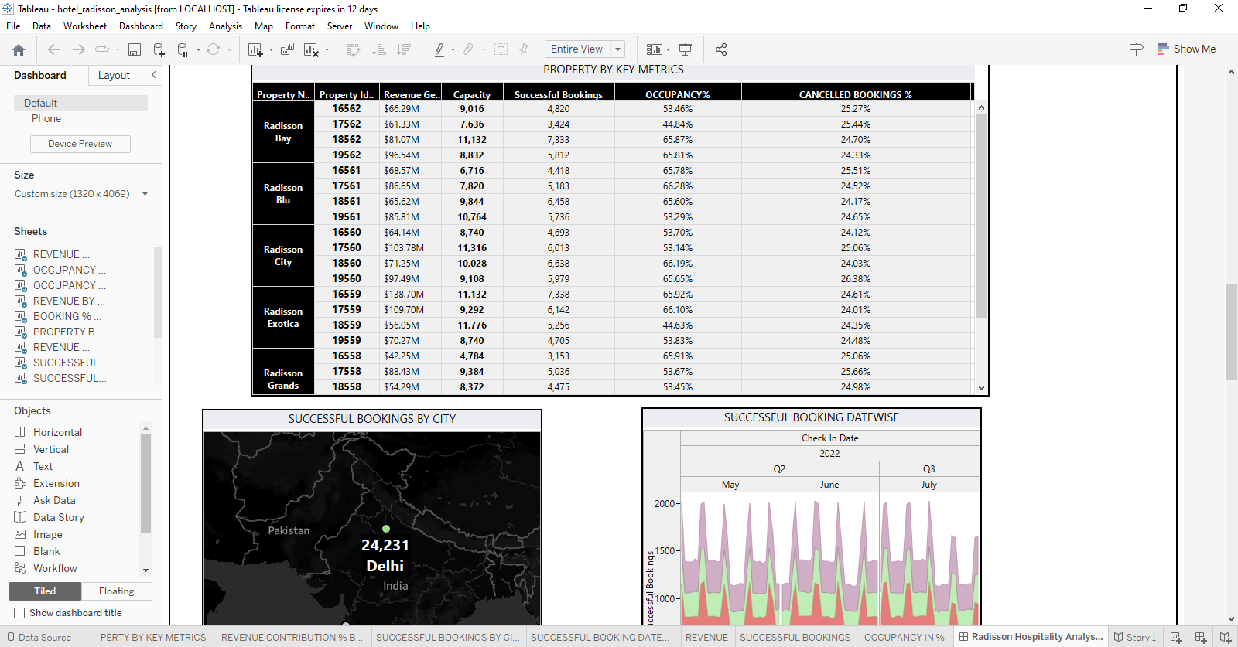

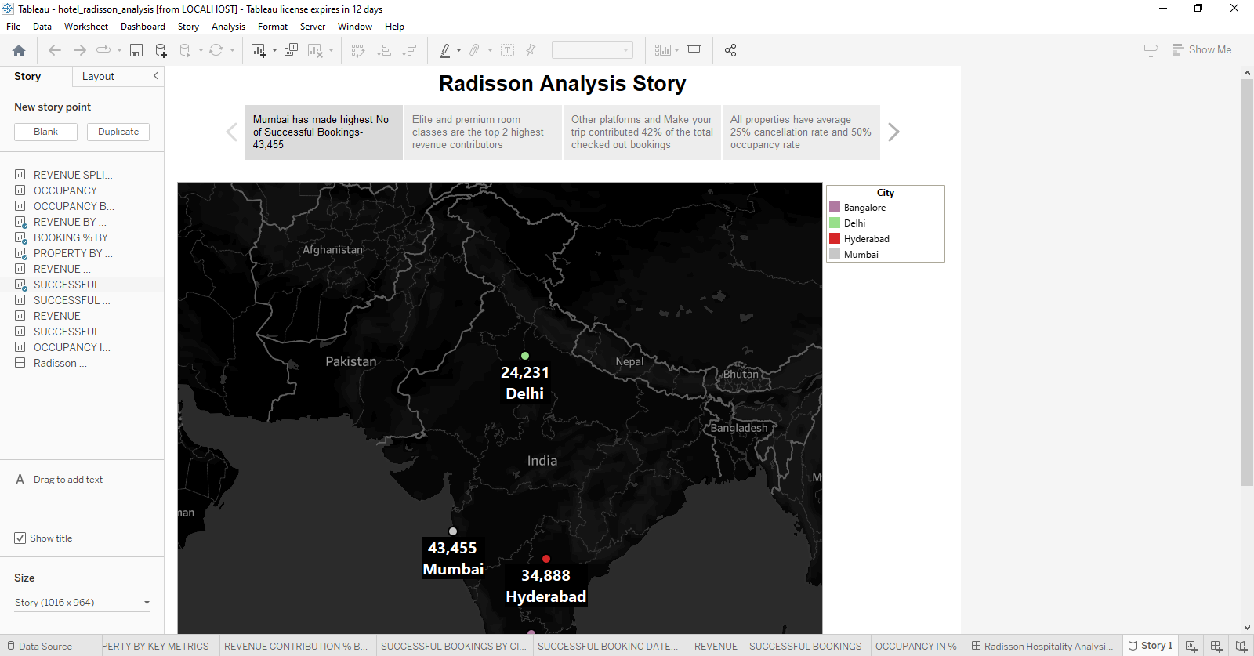

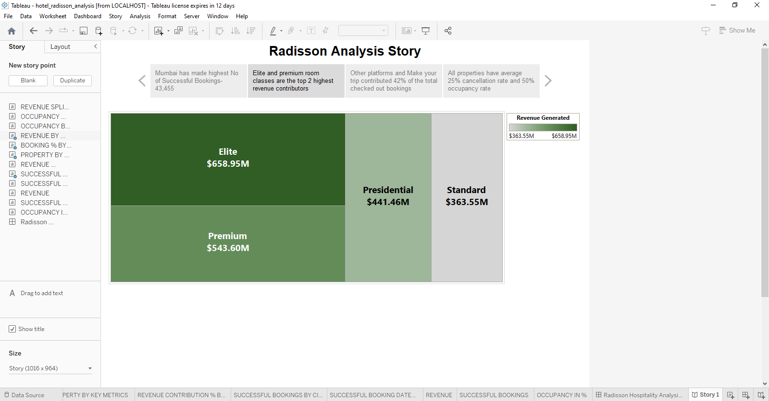

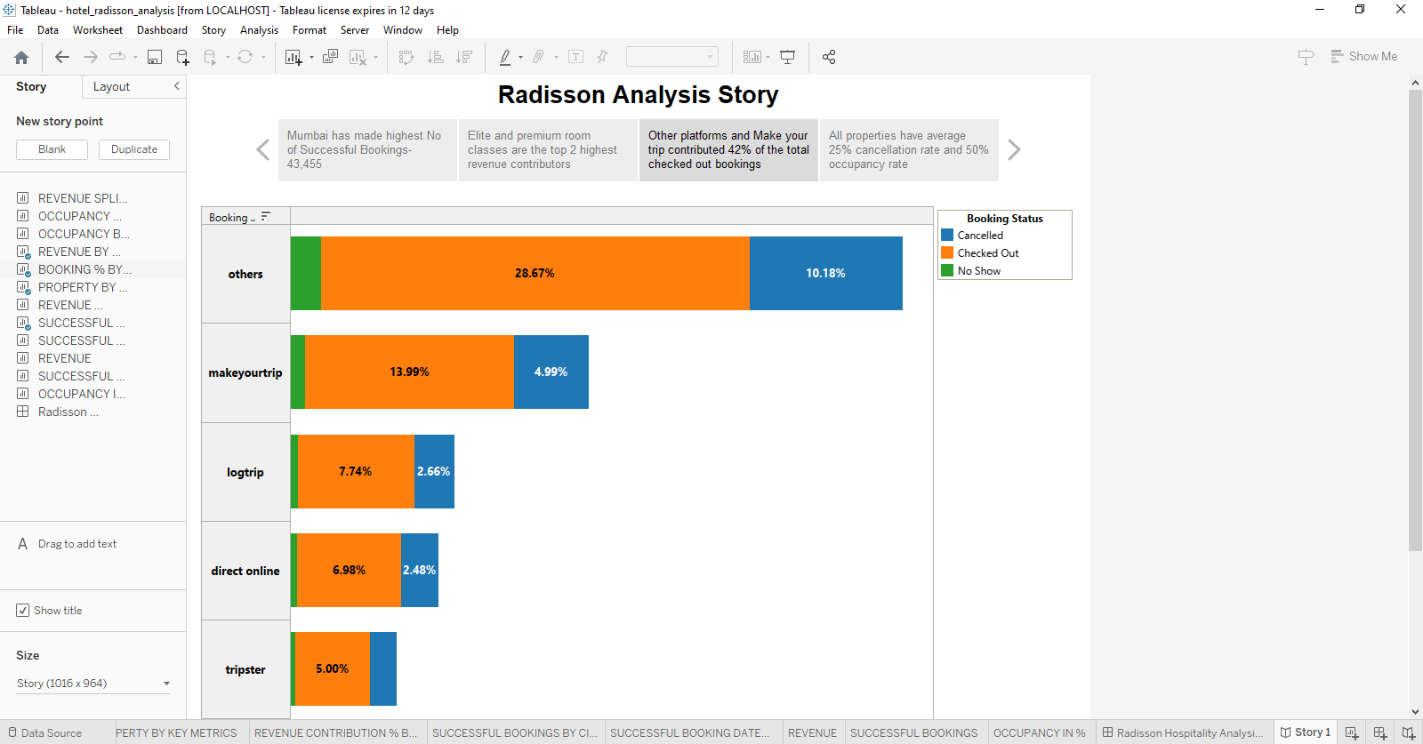

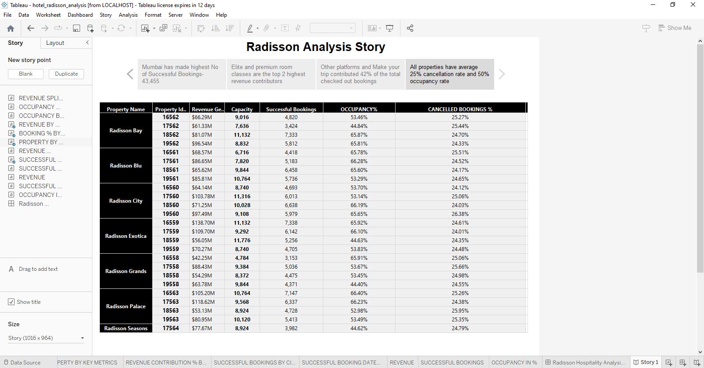

**ADVANTAGES AND DISADVANTAGES OF OUR PROJECT:**

ADVANTAGES:

* With us, you can book a reservation in advance or walk up to the hotel to find a room
* Our hotel has comfortable beds and bedding to ensure a good night’s sleep
* 24-hour reception and room service are just a phone call away
* Uniformed security patrol the hotel 24-hour a day, seven days a week to protect guests
* Our guests enjoy on-site entertainment such as the video arcade game rooms and Ozzie’s Splash Zone water playground
* We offer complimentary Wi-Fi access to help keep you connected with family and friends
* On-site restaurants and buffets to take the guess work out of lunch or dinner plans
* Guests experience the most indulgence next to our seasonally-heated swimming pools
* Complimentary scheduled shuttle services to nearby attractions offer convenient transportation

DISADVANTAGES:

Hotel rooms can be pricey, especially if you need to stay for a prolonged period of time. Travelling with a large group of people can become tricky too. You might not all be able to book rooms and if you do, chances are they will not be together in the building. You are also bound by the opening times of the bar and restaurant.

It can be difficult to find adequate levels of peace and privacy in a large chain hotel. Room checks are carried out unless you leave a ‘do not disturb’ sign on the door, and the walls can be so thin that you might be continually disturbed by noise from other guests.

**APPLICATIONS:**

**hotel management** is a set of operational processes that are simply aimed at improving customer service. As we have already seen, it controls other things at the same time and although it is true that customers are the ones who in the end benefit from it all, they are not the only ones.

We attempt to satisfy the needs of tourists, which involves quite a challenge; since each user has individual expectations. But we can say that ultimately customer satisfaction is most important.

To facilitate the process, a detailed analysis is usually conducted to ascertain customer service demand, all available products are classified (these are referred to as inventories), supplier system functioning is analysed as well as transport and storage management.

To carry out all these processes, comprehensive global and individual strategic planning has to be undertaken. For example, demand analysis will be studied based on supply. The idea behind this analysis is to be able to offer customers the kind of product they need, thus avoiding stock shortages, but at the same time that stock may be spoilt because too large an order has been placed.

To achieve **optimum hotel management**, the maximum possible market information must be available, such as socio-economic status, food and drink preferences, collective level of satisfaction, the type of tourist the hotel is targeting, accommodation packages and seasonality of demand, etc.

The most common course of action is to hire a [**hotel consultancy firm**](https://www.ihcshotelconsulting.com/hotel-consulting/) which undertakes to perform good  **hotel management aims**, controlling all the processes in detail. If this is not possible, you can always outsource the service, such that a specialist company, with a proven track record, can look after everything such as IHCS Hotel Consulting.

**CONCLUSION:**

Our long-term vision is **to be the company of choice for guests, owners and talent**. Whenever a guest plans a trip, or an investor or owner is thinking of a partner, or whenever someone is looking for a career in the hospitality industry, they will all think of Radisson Hotel Group first.

**Future scope:**

The scope of hospitality industry comprises a range of businesses that provide services and facilities such as accommodation, food and beverage, entertainment, gaming, and related products**.**